**Wearables API Research**

Stress Wearables

|  |  |
| --- | --- |
| **Date** | 12-10-2022 |
| **Version** | 0.1 |
| **Status** | Final |
| **Author** | Victoria Fong, Milan Koster, Michael Osuntuyi, Marinda Boshoff |

**Version**

|  |  |  |  |  |
| --- | --- | --- | --- | --- |
| **Version** | **Date** | **Author** | **Amendments** | **Status** |
| 0.1 | 19-09-2022 | V Fong | Initial setup of document and first ideas and sources | Draft |
| 0.1 | 10-10-2022 | M Boshoff | Added introduction, steps taken, given wearable, Suunto and some text in Movesense. | Draft |
| 0.1 | 10-10-2022 | V Fong | Added research into the sources Movesense, Thesis’s, Git projects and Fontys graduate projects. | Draft |
| 0.1 | 12-10-2022 | M Boshoff & V Fong | Finalised document | Final |

Contents

Introduction 4

Summary of steps taken 4

Research Plan 4

Given Wearable Device 4

Suunto 5

Movesense 6

Conclusion (Suunto & Movesense) 8

Online Thesis's 9

1. Prototyping with Movesense Platform – Breathing Application 9

2. Design Document Balance Health 9

3. Development & Evaluation of Heart Rate Sensor Software for team sports monitoring 9

GIT Resources 10

Solution for Movesense challenge by Suunto in Junction 2017 10

Fontys Graduate Projects 11

Movesense Showcase 11

Stress Measurement System 11

# Introduction

The goal of this document is to show the research done in order to connect the given wearable device directly to the platform. The ideal situation is one in which the wearable is worn by the patient/user and connected to a mobile application via Bluetooth. The mobile application then gathers data and offers an API to which requests for the data can be made.

# Summary of steps taken

1. Investigated Suunto’s API
2. Investigated Movesense’s Sensor API
3. Demonstrated findings to product owners
4. Investigated mobile applications.

# Research Plan

**Question**: How can data gathered from the Suunto heartrate belt be extracted?

|  |  |  |  |
| --- | --- | --- | --- |
| **Methodology** | **Strategy** | **Approach** | **Outcome** |
| Library | Literature study, Expert Interview | Documentation regarding finding and using open data of the stress wearables devices. | Found and received documentation that is useful to get started into the data that will/could be used for the project. |

# Given Wearable Device

Suunto Smart Heart Rate Belt[1] with Movesense sensor [2]for heart rate monitoring.

Movesense Sensor HR2 Model OP174.

# Suunto

Suunto is the brand on the wearable device’s strap and when looking further into the brand it becomes apparent that Suunto is the parent company of Movesense. Suunto has an API Zone[3] that provides information on how their API can be used. In order to get access to Suunto’s API, a company or organisation has to apply[4] to become a Suunto partner. A Suunto partnership is for companies or organisations who will be providing tools/apps or services for a public audience.

Once a company or organisation has been approved by Suunto to join their partner program, they can start developing with a limitation on the number of calls that can be made to the API. Later an application must be submitted to gain access to a production version of their API and the application can be published to Suunto.com.

**Contact with Suunto’s support desk**

***Fig 2: “Suunto support”***

**Research Conclusion**

As a team we filled in an application to join Suunto’s partner program but we have concluded that we are unlikely to be accepted into the partner program and as of writing this document we have not received any response from Suunto.

# Movesense

*Movesense* an open-source platform based on sensor devices for sports, health, research, manufacturing and more. With the sensor device, developers can build their own wearable solutions or personal projects. *Movesense* has a good amount of documentation[5] regarding the use of their hardware for personal projects.

Further, *Movesense* has YouTube videos [6] to how to run a basic project with the sensor.

***Fig 1 “Movesense Developer Resources page”***

**Research Conclusion**

We have done research, gone through their documentation and tried their setup YouTube tutorial to initialize a connection to the wearables for live data. Movesense does not provide an REST API from which collected data can be gotten. Instead Movesense provides an API for their sensor to extract data from the hardware via a Bluetooth connection with a mobile device.

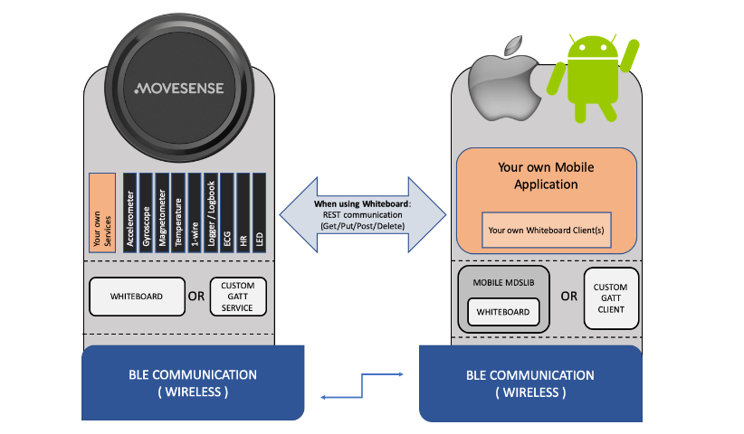

***Source: https://www.movesense.com/docs/system/system_overview/***

Due to the reason that the sensors need to be connected to a mobile device and we have little no knowledge of mobile development, we had no luck in setting up a live connection to the wearables. So instead of developing a mobile app to connected with the Movesense sensor, we decided to mock the data the wearables sent out to use for our project.

**Mocking the data**

Movesense has an app for both iOS and Android called ‘Movesense Showcase’ that is made for development purposes. By connecting the wearable device to Movesense Showcase, data can be collected and manually exported.

In order to mock getting data from an API, we have created a small basic application that will return the exported data we collected and exported through the Movesense Showcase app.

**Extra sources for Movesense**

Using DotNet with Movesense: [https://githubcom/AndyCW/MovesenseDotNet](https://github.com/AndyCW/MovesenseDotNet)

Movesense Get Started: <https://www.movesense.com/get-started/>

## Conclusion (Suunto & Movesense)

We looked into documentation that could be helpful for getting open-source data from the wearables to use for the project. After doing some online research into Suunto (the company that manufactures the bands), we found documentation regarding their APIs.

After contacting Suunto contact support, we where informed that to get access to their data, we would need to fill in an application form. We would need to wait to get access to Suunto’s API which will take approximately 2 weeks.

By contacting one of our stakeholders, Manon Scheepers we were informed that there is another resource, Movesense, we can use to retrieve the data without signing up.

Looking through the Movesense documentation from the source of the stakeholder we realized there was a lot of documentation to go through. We took two approaches, one to try out examples of the documentation and the second to contact the company for further questions regarding understanding their work.

# Online Thesis's

We were curious to see if other developers have tried using the *Movesense* sensor for their personal projects to see if they had more descriptive documentation compared to the *Movesense* platform. We came across the following 3 thesis’s:

## 1. Prototyping with Movesense Platform – Breathing Application

Link to thesis: [Prototyping with Movesense Platform – Breathing Application](https://www.theseus.fi/bitstream/handle/10024/222004/Lofblom%20%20Johanna.pdf?sequence=2)

**Summary**

The thesis explores movesense platform for development of wearable solutions. It touches down on research regarding movesense architecture, device, mobile app, setting up movesense system, building movesense device apps and movesense community project and plugins.

The outcome of the thesis was four prototypes implemented. The thesis gives well-documented research of movesense and might be helpful into creating the mobile device using the sensor.

## 2. Design Document Balance Health

Link to thesis: [Design Document Balance Health Thesis](https://showcase.itcarlow.ie/C00133947/documents/DesignDocument.pdf)

**Summary**

This thesis touches down on the application design and usage. It describes the systems hardware and software architecture, contain class diagrams and sequence diagrams to demonstrate the structure and interaction as well as wireframe to illustrate the user’s interface for the application.

The thesis mainly describes the application’s design which can give insight to ideas of developing an application with the sensor.

## 3. Development & Evaluation of Heart Rate Sensor Software for team sports monitoring

Link to thesis: [Development and Evaluation of Heart Rate Sensor Software for team sports monitoring](https://core.ac.uk/download/pdf/250165891.pdf)

**Summary**

The goal of the thesis is developing and evaluating a sensor solution to monitor and analyze the heart rates of elite team sports. Besides touching down on the sports team, the project is based on, the document can be useful for understanding and having an example for building an application with using the movesense heart belt sensor. Some useful information the thesis may provide is a summary of the movesense platform, architecture of movesense library, build process & flashing of an application, memory mapping & resource usage, whiteboard (movesense framework) & rest API in movesense library and lastly the development of the application is.

# GIT Resources

## Solution for Movesense challenge by Suunto in Junction 2017

Link to GitHub project: [Solution for Movesense challenge by Suunto in Junction 2017](https://github.com/yalchinAlv/MovesenseConnect)

**Summary**

This git repository project is based on the winning group project of movesense hackathon event where they have created a webapp that allows coaches to manage multiple teams and to see the biometric data in real time about all the member of the active team.

The project could be useful for some ideas into setting up a project with using the movesense heart rate sensor.

## Fontys Graduate Projects

These projects can be found by contacting Manon Scheepers which is one of the stakeholders of this project. Below we explain each graduate project which can be useful for creating a base project using the movesense heart rate sensor.

### Movesense Showcase

This project is based on a graduation project where they have created an application to work with the movesense device to get the retrieved data.

To run the project, you would need to connect an android device specified in the document for the Bluetooth connection with the sensor. We have tried to connect the project to two devices (Redmi 10 and Oppa) of our team members but with little to no success, the devices could not get the app running where the installation went wrong.

We believe that the applications functions but that we don’t have the correct the devices to support the application where we could not use the project.

### Stress Measurement System

This project does not document well how to run the project but indicated what has to be running to be able to use the made application. Due for the reason that it will take too much time to try and run the project without well documented work, we chose as a group to not dive to deep into trying to run the project as developers that are not specialized in android development.

1. https://www.suunto.com/Products/Heart-Rate-Belts/suunto-smart-heart-rate-belt/
2. https://www.movesense.com/product/movesense-sensor-hr2/
3. https://apizone.suunto.com/
4. <https://www.surveygizmo.eu/s3/90115093/PARTNER-Become-a-Suunto-Partner?_ga=2.112277700.153577044.1550744656-167818067.1547462409>
5. https://www.movesense.com/resources/
6. https://www.youtube.com/channel/UCbgPW6XDhLTZDIR97vazw1g